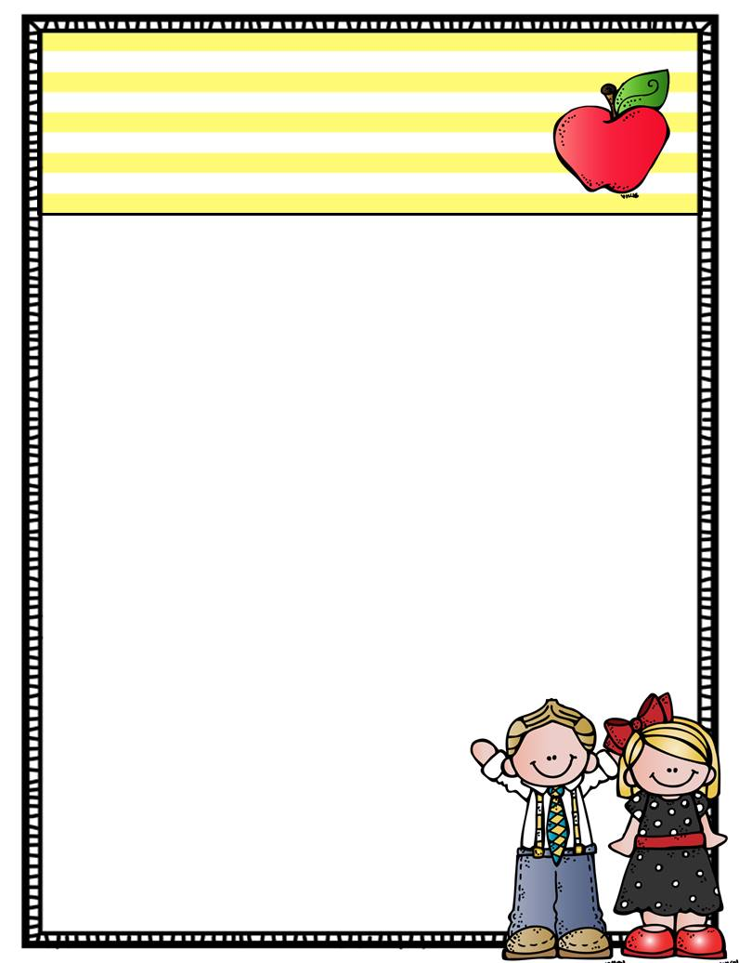

Thank You,   
**Miss Perkins & Miss Arnold**

Dates to remember

25th April – ANZAC DAY – No School

3rd May – Cross Country – Wear House Colours

4th May – Seawinds Excursion

5th May – Coach Approach

12th May – Mothers Day Stall

21st – 27th May – Education Week

Home Learning

Mathletics and Reading Eggs are online resources that can be used at home, students should have their codes in their reading logs.

Coloured Oxford Wordlists are being updated and sent home regularly. Students will be tested fortnightly on these. To progress to the next colour they must get at least 7/10.

Reading assessments are with a teacher and usually go for 10- 20 minutes per child. With the new coloured level system your child may not move colours for a while as each colour represents 3-4 levels. A focus for Year One reading is comprehension so we encourage you to ask questions after reading to help develop understandings.   
If you have questions about this please feel free to come and see us.

We have begun to work very intensively on handwriting, letter formation and number formation in the classroom. We may send home activities in learning at home books for extra practice.

What’s Happening…

Our inquiry topic for this term is called “tiptoe through our world” concentrating on sustainability, reducing, reusing, recycling and leaving a light footstep on our planet. Students will visit Seawinds and explore the bushland and gardens there as well as our beach to compare the different environments   
in our local area.

Year One

Term Two News

A Note from the Teachers

Welcome back to all our families, we hope you enjoyed the holidays! A big thankyou to all the parents who sent in resources for our fine motor kits. We have finally put them together and will begin using them this week. Due to safety reasons students and parents are not able to enter any classroom without a teacher present, our doors will be open at 8:50am each morning. However some mornings we have meetings. We thankyou for helping us out with this.